  To this !  OUR CLASSIC  DETAILERS  will make your  car feel like NEW!  DID YOU KNOW???  Q: I wash my vehicle at home using a garden hose. Lately, the finish looks dull and marked. What could be wrong?  A: Washing your vehicle at home is extremely harmful to the finish. The University of Texas proved that a single home hand-wash can leave scratches in your finish as deep as 1/10 of the paints total thickness. Also, the average garden hose cannot supply enough water and water pressure with the detergent action to avoid damaging a vehicle's finish.  This important study concluded that automobile owners should avoid washing their vehicles at home. Only a professional car wash can provide the proper amounts of water and water pressure needed along with the appropriate soaps and waxes to safely and effectively clean your vehicle. |  |  | ADDITIONAL SERVICES AVAILABLE  AT OUR DETAIL SHOP:  DEODORIZING – We guarantee the removal of smoke odors when we use an O-Zone machine  FABRIC PROTECTANT  PAINT & TAR REMOVAL  OXIDATION REMOVAL  HIGH SPEED POLISHING  PAINT SEALANT TREATMENT  FLOOD RESTORATION  BOAT, SEMI-CAB AND AIRPLANE CLEANING  We support equal opportunity. |  |  |  | Take your car from this….  Mr. Clean’s  CLASSIC  DETAILERS  • • • • • • • • • • • • • • • • • • • • • • • • •  600 WEST 23RD STREET  YANKTON, SD 57078  [605] 665-1828  COUPON  FREE  CAR WASH WITH ANY DETAIL!
Detailing |  |  |  | Interior Cleaning |  |  |  | Exterior Express
 |  |  |  | Upholstery – Vacuuming & Steam Cleaning |  |  |  | (Routine Maintenance)
 |  |  |  | the seats, wiping down the  dashboard, wiping down the doors. |  |  |  | Hand Washing of Vehicle  $39.95 up to $59.95*
Classic Interior Detail Includes: |  |  |  |  |  |  |  | Hand washing of vehicle includes:
 | Door Jams |  |  | Carpet – Vacuuming and Steam Cleaning of |  |  |  | Hand power washing the vehicle,
 | Floor mats cleaned & protected |  |  | Carpets. |  |  |  | washing of all windows-inside & out,
 | Wipe down dashboard |  |  |  |  |  |  | towel drying.
 | Windows & mirrors cleaned |  |  | Small Trucks, Cars, Compacts & |  |  |  | RainX™ Black Magic™ Express Wax™.
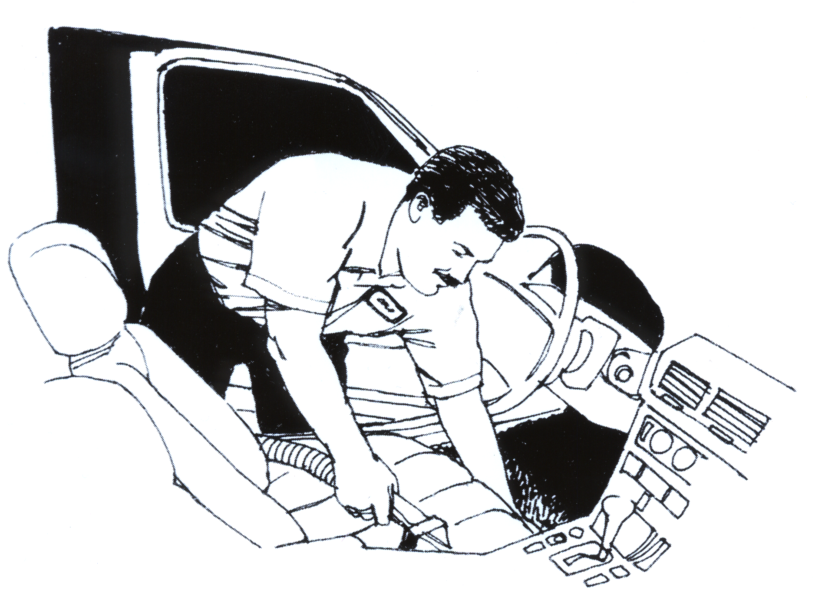 | Door panels & side walls cleaned |  |  | Sports Cars |  |  |  | Maintain interior with Interior Express  (Routine Maintenance)  $39.95 up to $59.95*
 | Trunk Vacuumed |  |  | Upholstery | $39.95 *
 | Interior Vinyl Cleaned and dressed |  |  | Carpet | $39.95 *
 | With polyprotectant (No silicone) |  |  | Sedans, Sport Utility & Standard
 | Fabric/Leather Upholstery cleaned |  |  | Pickups
 | Carpets cleaned & protected |  |  | Upholstery |  | $49.95 *
 |  |  |  | Carpet |  | $49.95 *
Interior Detail |  | $94.95 – 139.95* |  | Full Sized Sedans, Suburban, Vans &
 |  |  |  | Extended Cab Pickups
Classic Exterior Detail Includes: |  |  |  | Upholstery | $64.95 *
 | Hand Power Wash vehicle |  |  | Carpet | $64.95 *
 | Towel dry
 | Wash windows inside & out |  |  | * The above quoted price does NOT
 | Basic bug removal |  |  | include restorative cleaning |  |  |  | - Vacuuming upholstery & carpets
 | Clean chrome & front grill |  |  |  |  |  |  | - Wipe down the dash & doors with
 | Tires & trim cleaned & dressed |  |  |  |  |  |  | professional protectant & apply deodorant
 | Application of clear coat protectant |  |  |  |  |  |  | - Wash windows & mirrors
 | Hand polish entire vehicle
 |  |  |  |  |  |  |  | NOTE: Headliners & Sunvisors are
Exterior Detail |  | $79.95 - $129.95* |  |  |  |  |  | NOT cleaned in this shop.

ALL SERVICES ARE AVAILABLE BY APPOINTMENT ONLY!!

