Date: _________________________________

Name: ________________________________

Address: _______________________________

_______________________________

City: _________________ State: ____________

Zip Code: __________________

Phone : _____________________________

Your suggestion can make a difference. Please take a moment and tell us what we can do to make things better for you. Thank you.

Suggestions: ________________________________

___________________________________________

___________________________________________

___________________________________________

___________________________________________

*___________________________________________*

___________________________________________

___________________________________________

___________________________________________

___________________________________________

___________________________________________

___________________________________________

Customer Suggestion Form

How To Get

A Better

Car Wash

Customer Service Department

Classic Car Wash

Super Suds

Eco Auto-Wash

K-9 Pet Wash

Your Fast Pass to Successful

Car Washing

Self Serve Wash

1. Obtain U.S quarters.

2. Slowly insert eight or more quarters one at a time.

3. Wet car surface with pre-soak.

4. Scrub vehicle using brush.

5. Select wash cycle.

6. Select rinse cycle.

7. Select spot free rinse.

8. Drive into lot and towel dry.

Automatic Car Wash

1. Use exact change only.

2. Push button first then insert payment. One bill at a time.

3. Wait for enter light to flash.

4. Put front driver wheel in wash position. Stop light will shine. Put in park position

5. Car Wash machine will operate until finished.

6. Drive into lot and towel dry.

**All adopted suggestions will receive three free washes.**

**Please help us Give You**

**Our Best Service.**

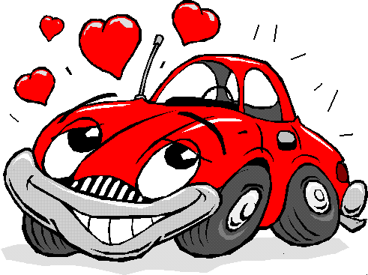

Pressing Button 6HoseCo-WorkersCar Wash 4

More Helpful Hints

Automatic Car Washing

__ Push wash selection button first, then insert token, followed by coin or cash if you are upgrading.

__ Buttons must be pushed deeply and message screen

must acknowledge request to insure service.

**__** Paper tokens and coin tokens have no cash value. Please do not push refund button. when using refund for tokens. If you push refund after inserting money or tokens you will zero out your wash purchase. The machine will not refund due to Criminal Tampering.

__ You can upgrade your token wash by adding coins or bills. You will always get the value of the token with an upgrade.

__ Wait for **ENTER** light to flash before you enter the wash tunnel. Proceed forward until the stop sign lights. Your vehicle front will be on the start pad.

__ Haze after washing? Road grime creates a barrier which prevents adequate cleaning. Thoroughly towel dry your vehicle by hand after every 3rd wash.

__ Please observe size limitations before entering wash bays.

__ Machine arms don’t need to rotate to get a good wash.

__ If trailer hitches get in the way of the automatic car wash

equipment sensors will stop the wash. Please remove before

washing any antenna or ornaments. They will stop the wash..

**__ Due to Criminal tampering exact change must be used**

Self-Service Bays

__ Rinse foam brush before using.

__ Wands have 1200 lbs of pressure. Please exercise caution when you spray.

__EXIT stall doors are down on inclement

weather days. Please back out.

Your satisfaction is important to us. We want your visit with us to be an enjoyable

experience

Customer Service Department

Classic Car Wash

Magic Wash

Super Suds

Five service personnel maintain the washes everyday. We try to keep all 20 vacuums, 9 self-serve bays and 5 automatic car wash systems operating at their best at all times. We are open 24 hours a day, seven days a week, weather permitting.

Vacuuming

__ Pick up jewelry and change before vacuuming.

__ Vacuum coin acceptors get jammed with Canadian quarters, dimes, nickels and pennies. Hoses can get plugged with pens, pencils, straws, napkins, etc.

__ Floor mats are the most commonly forgotten item at the car wash. Vacuum them and put them back right away.

**Vacuums are meant for dry cleanings only. Do not use vacuum for wet pickup. Damage or personal injury can result.**

Change Machine

Operation

__ Change machines get jammed with old, flimsy, damp or dirty bills or Canadian money. Please use good, clean, flat bills and always use U.S. currency, never Canadian.

__ Crease the center of the bill lengthwise. The reader will see the currency better.

__ The change machine accepts 1’s, 5’s 10’s only.

**__ Due to criminal tampering the change machines operate from sun-up to sun-down only**.



N-K Properties, Inc. 610 Broadway Avenue, Yankton, SD (605)665-1828