Glass ○ Chrome ○ Trim ○ Paint

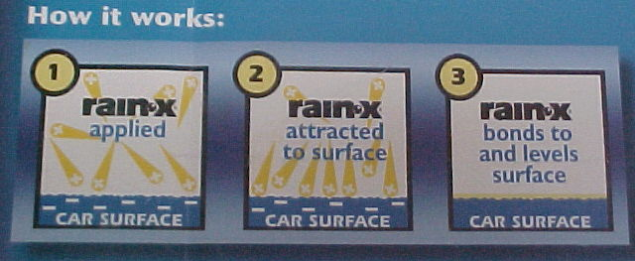

Shines

Enhances Visibility

Repels

Less Toweling

Applied
During
Car Wash

Protects

Less Streaks

Complete Surface Protection
Rain-X Online Protectant is a revolutionary new
Formulation of surface reactive silicones and other polymers to
Create the industry’s first complete surface protectant!
This representative diagram shows how Rain-X Online Protectant is
Chemically attracted to the surface of the vehicle immediately after application. Rain-X Online Protectant then levels the microscopic irregularities of the glass or paint to provide increased shine and water repellency. Within 24 hours, Rain-X Online Protectant is cured to provide longer lasting protection compared to conventional clear coat protectant products, which simply sit on the surface of the paint.
You’ll have a cleaner, shinier car longer when you choose Rain-X

